AI ASSISTANT CODING
ASSIGNMENT-16
Name: Thrishala Jakkaraju

Hallticket:2303A51514
Batch:22
Task Descrption-1: (Design Database Schema for Student Management System) Instructions:
- Using AI tools, generate CREATE TABLE statements for a Student Management Database.
- Tables: Students, Courses, Enrollments.
- Include primary keys, foreign keys, and suitable data types. Ensure the schema follows normalization rules (1NF, 2NF, 3NF). Code:
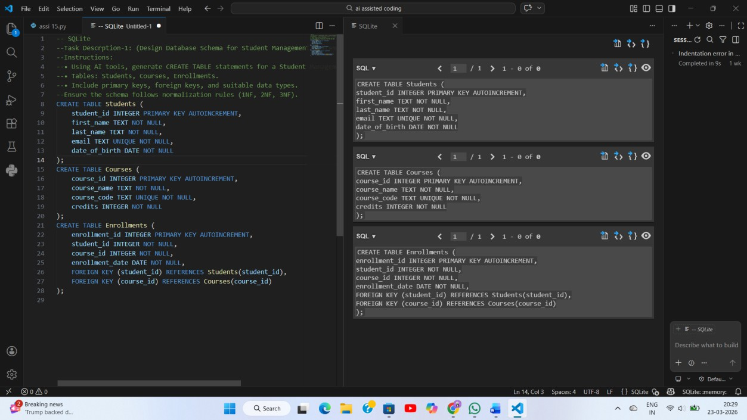

Task Description- 2: (Insert Sample Records) Instructions:
- Use AI tools to generate INSERT statements to populate the tables.
- Insert at least 3 students, 4 courses, and 5 enrollment records.

Verify data using SELECT queries.

Code:
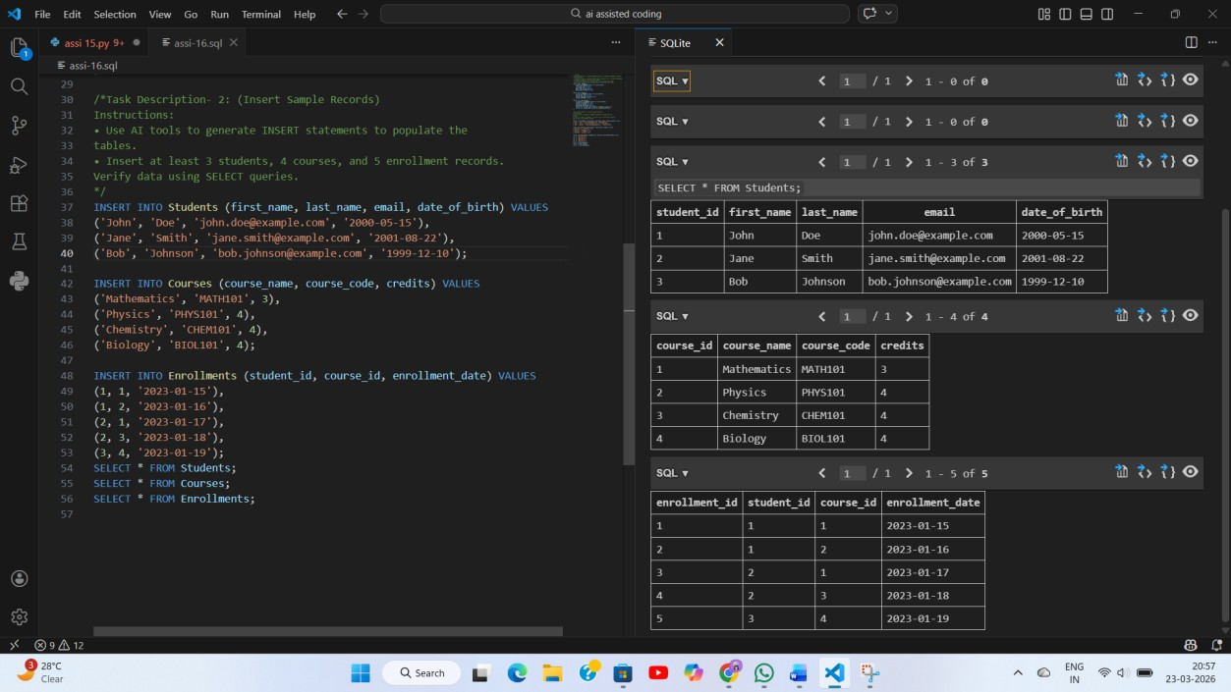
Task Description- 3: (Perform CRUD Operations) Instructions:
Use AI to generate SQL queries for basic CRUD operations:
- Retrieve all courses
- Update a student’s email
- Delete an enrollment record
- Validate the changes using SELECT statements.

Code:

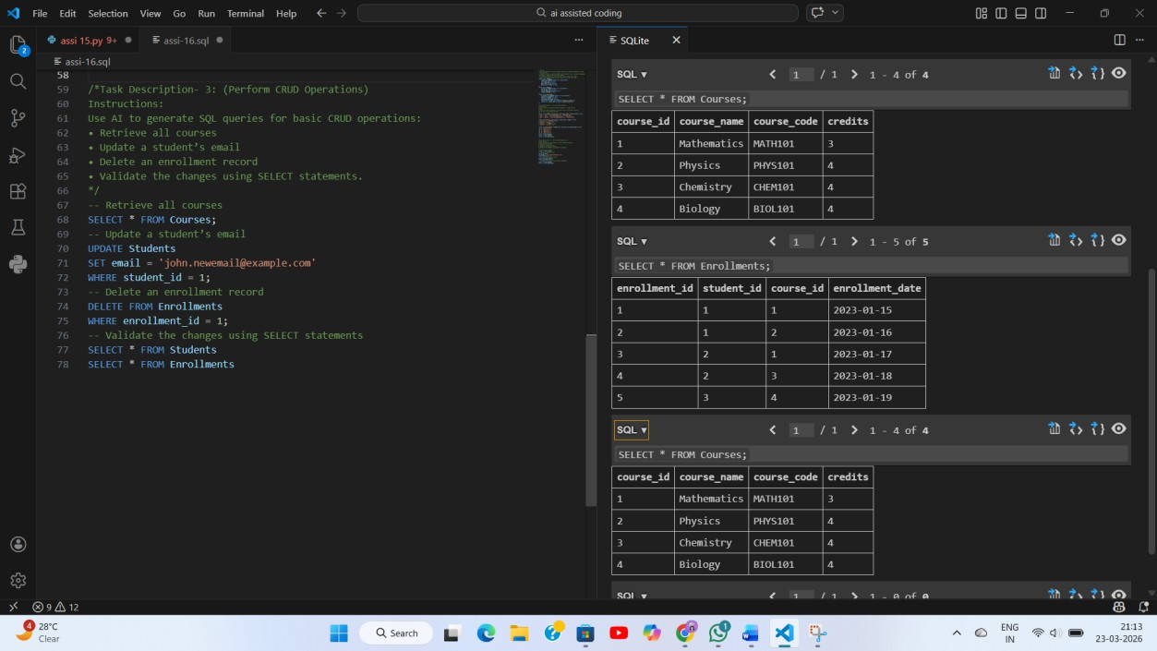
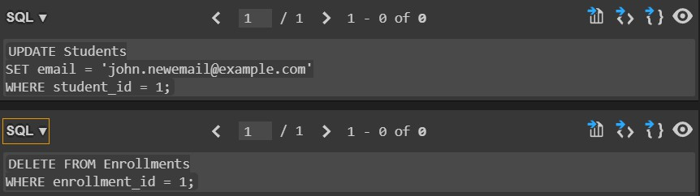

Task Description- 4: (Execute Aggregate Queries) Instructions:
Use AI tools to write aggregate queries:
- Count number of students enrolled per course
- Display courses with more than one student enrolled Analyze the correctness of results.

Code:

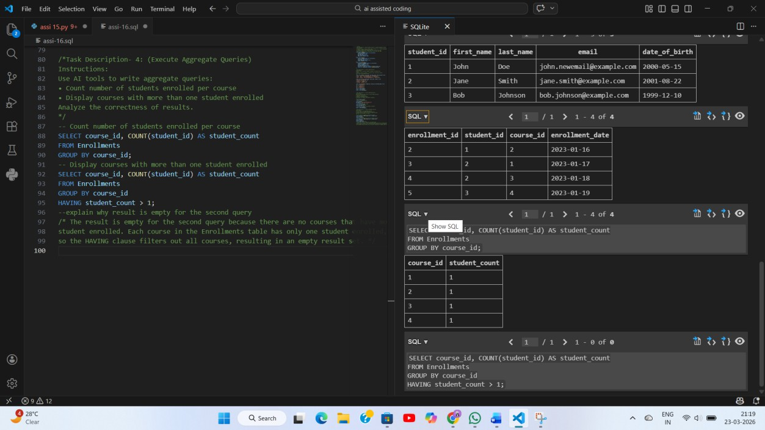

Task Description- 5: (Query Optimization) Instructions:
- Use AI tools to analyze query performance.
- Rewrite inefficient sub queries using JOINs and test both queries for correctness.
Code:

